**R Code for Examples in the book**

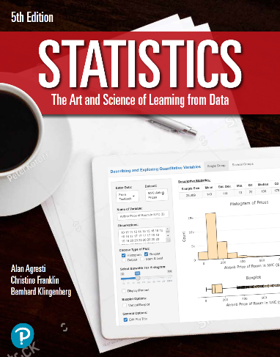

***“Statistics: The Art and Science of Learning from Data”***

**by Agresti, Franklin and Klingenberg, 5th edition**

**Chapter 14**

**Example 3: Telephone Holding Times – One-Way ANOVA**

## Reading in data

y <- c(5, 1, 11, 2, 8, 0, 1, 4, 6, 3, 13, 9, 8, 15, 7)  
group <- rep(c('A', 'M', 'C'), times = c(5, 5, 5))

## To find value of F test statistic that would have a P-value of < 0.05

qf(0.95, df1 = 2, df2 = 12)

## [1] 3.885294

## To get the ANOVA table

myAnova <- aov(y ~ group)  
summary(myAnova)

## Df Sum Sq Mean Sq F value Pr(>F)   
## group 2 149.2 74.6 6.431 0.0126 *  
## Residuals 12 139.2 11.6   
## ---  
## Signif. codes: 0 '***' 0.001 '**' 0.01 '*' 0.05 '.' 0.1 ' ' 1

## Given the F statistic, you can also compute the P-value using the pf() function

pf(6.43, df1 = 2, df2 = 12, lower.tail = FALSE)

## [1] 0.01264971